**Subject: PRF192- PFC**

**Workshop 04**

**Objectives:**

1. Managing data using pointers
2. Developing programs using simple menus

**Part 1: Use notebook**

**Exercise 1** (1 mark) : Explain outputs:

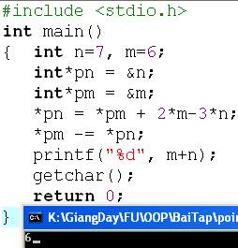

*pn = &n => pn = 7

*pm = &m => pm = 6

*pn = *pm + 2*m – 3*n

⬄ n = 6 + 2*6 – 3*7 = -3

*pm -= *pn

⬄ m = 6 – (-3) = 9

* m + n = 9 – 3 = 6

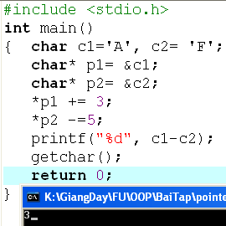Theo bảng mã ascii ‘A’ = 65

‘F’ = 70

*p1 += 3 ⬄ c1 = 65 + 3 = 68

*p2 -= 5 ⬄ c2 = 70 – 5 = 65

=> c1 – c2 = 68 – 65 = 3 ( in ra màn hình kiểu thập phân %d)

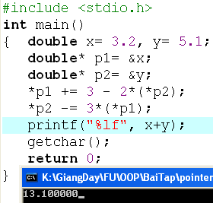

*p1 += 3 – 2*(*p2)

⬄ x = x + 3 – 2*(y)

⬄ x = 3.2 + 3 – 2*(5.1) = -4

*p2 -= 3*(*p1)

⬄ y = y – 3*(x)

⬄ y = 5.1 – 3*(-4) = 17.1

* x + y = -4 + 17.1 = 13.1

**Exercise 2: (1 marks) What are outputs**

Output = 8

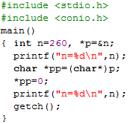

Output :

n=260

n=256

**Exercise 3: (2 marks) Walkthroughs**

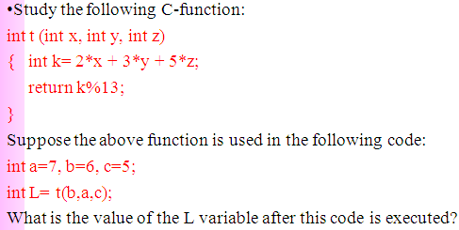

L = 58

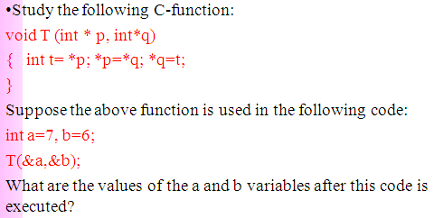

a=6

b=7

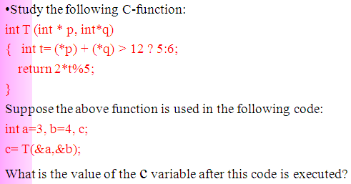

c=2

**Part 2: Develop a program using simple menu**

**Program 1(3 marks):**

|  |  |
| --- | --- |
| **Objectives** | Practice implementing a program with simple menu. |
| **Related knowledge** | None |
| **Problem** | Write a C program that will execute repetitively using a simple menu as following:   1. **Process primes** 2. **Print min, max digit in an integer;** 3. **Quit**   **Select an operation:**   1. When user selects the option 1, the program will accept a positive integral number and print out a message about whether the input number is a prime or not. 2. When user selects the option 2, the program will accept a positive integral number and print out the minimum and maximum digit in this number. 3. The program will terminate when user selects the option 3. |
| **Analysis** | **Nouns:**  - positive integral number 🡪 **int n**  - A number represents a choice of user 🡪 **int choice;**  **Functions**:  **int prime( int n) 🡪 see above**  **void printMinMaxDigits( int n) 🡪 see above** |
| **Suggested algorithm (logical order of verbs)** | Begin  Do /* Print out the menu and get user choice*/  { Print out “1- Process primes\n”;  Print out “2- Print min, max digit in an integer \n”;  Print out “3- Quit\n”;  Print out “Select an operation:”;  switch(choice)  { case 1: do  { Input n;  }  while(n<0);  If ( prime(n)==1) Print “ It is a prime\n”;  Else Print “ It is not a prime\n”;  break;  case 2: do  { Input n;  }  while(n<0);  printMinMaxDigits( int n) ;  break;  }  }  while ( choice >0 & choice<3);  End |

**Program 2(3 marks): ( refer to the workshop 2 for algorithms)**

Write a C program that will execute repetitively using a simple menu as following:

**1-Fibonacci sequence**

**2-Check a date**

**3-Quit**

**Choose an operation:**

1- When the option 1 is selected, the program will accept a positive integral number, called as n, then the first n Fibonacci numbers will be printed out

2- When the option 2 is selected, the program will accept a date then the program will tell that whether this data is valid or not.

3- If the option 3 is selected, the program quits

**More Programs**

You can pick 2 or 3 functions in the workshop 2, associate them to a new program.

